Task 2 - Snowflake Hands On Demo

- Creating a snowflake trail account and create a warehouse for our own
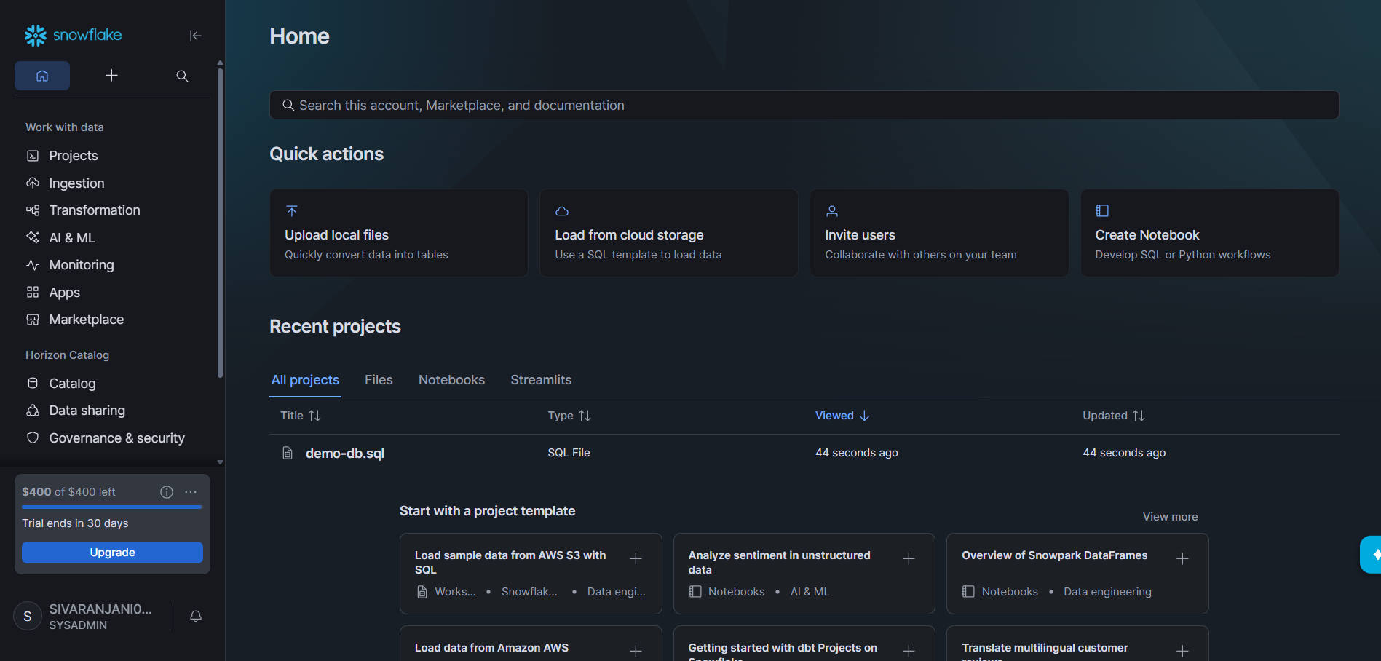

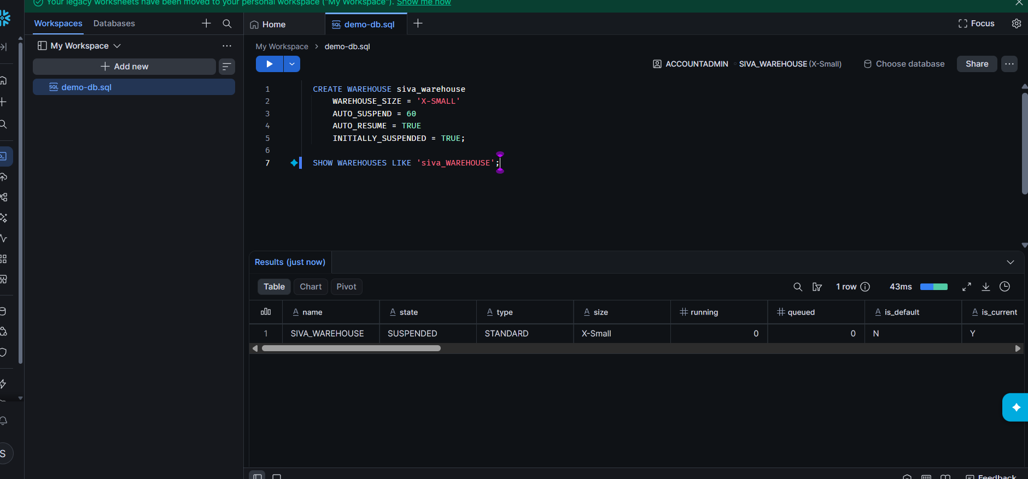

- Create a database and schema and show
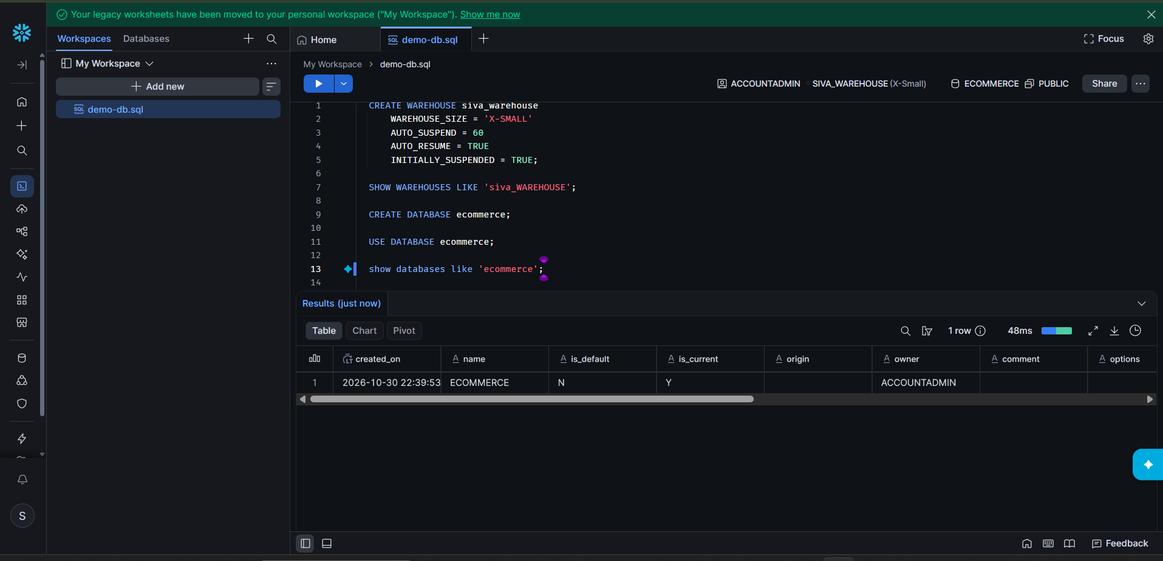

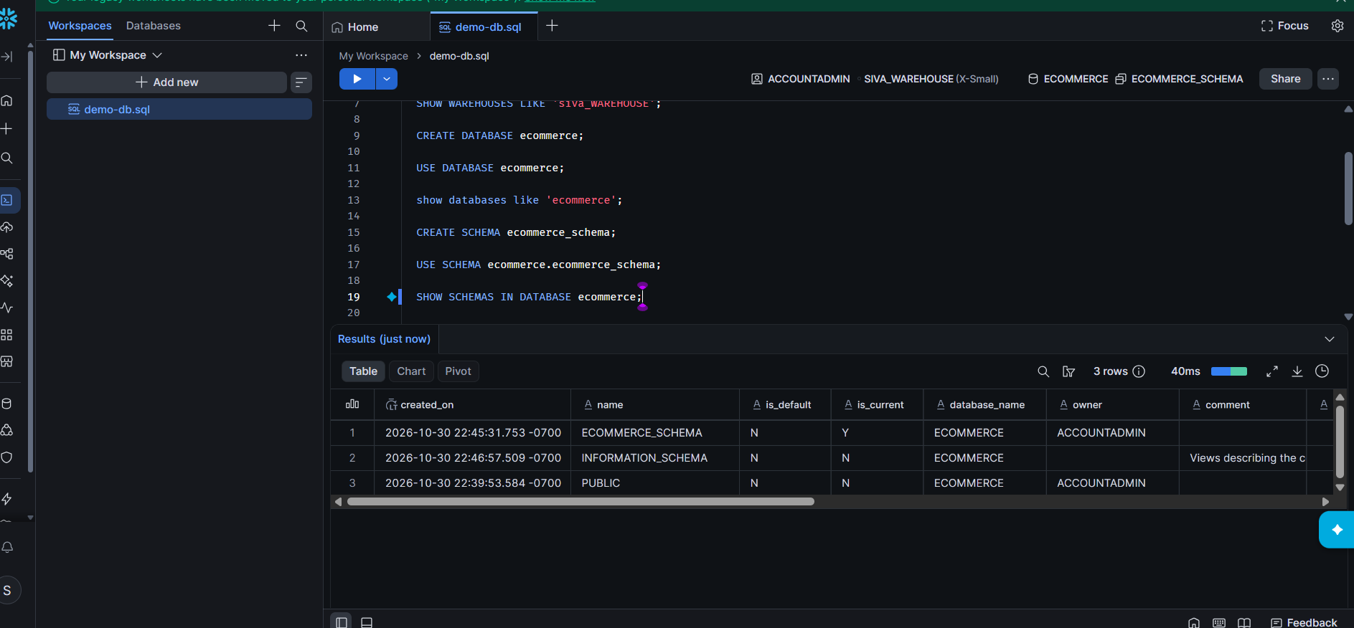

- Create a table inside the schema and show the details
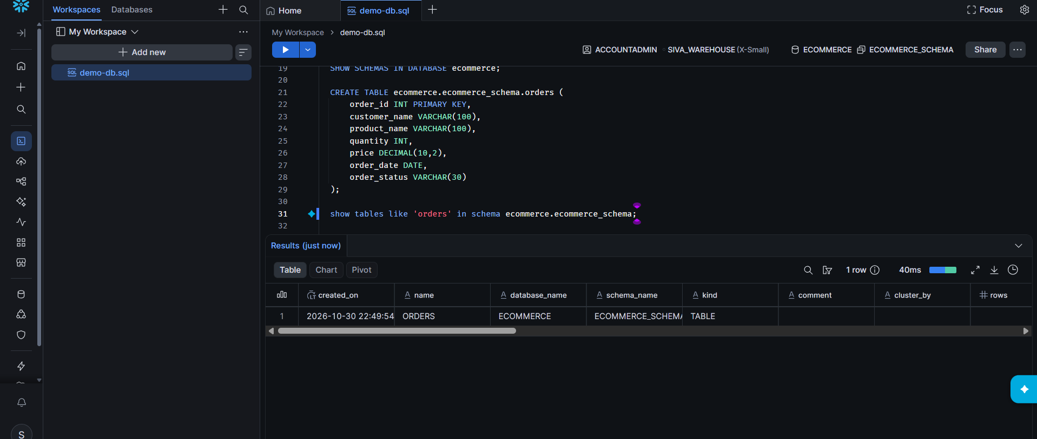

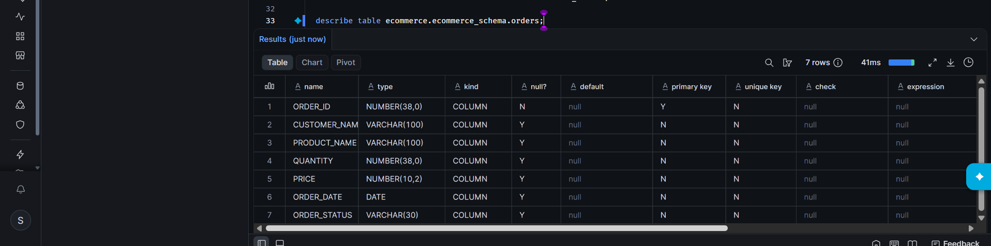

- Create a file format and stage

File format order_csv_format created
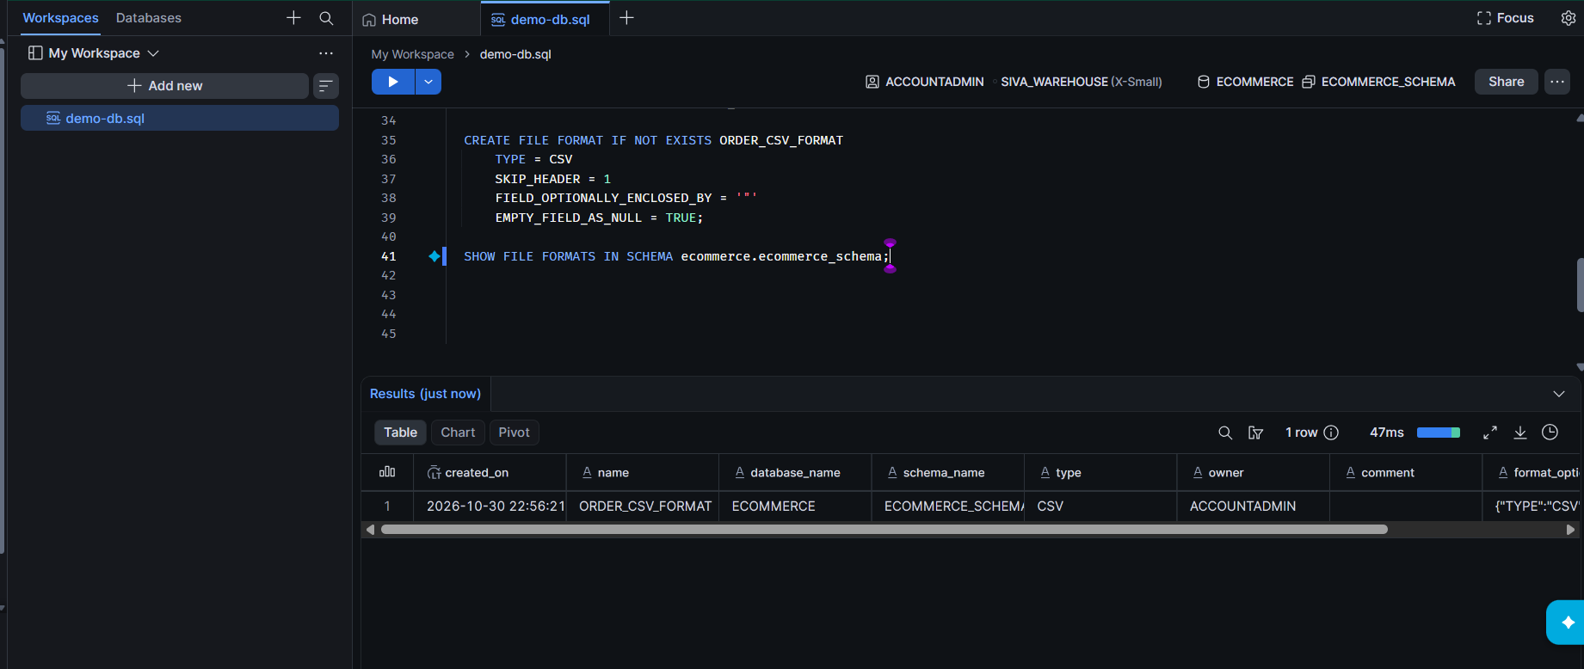

Created a stage ecommerce_stage with the file format we created for uploading our dataset.
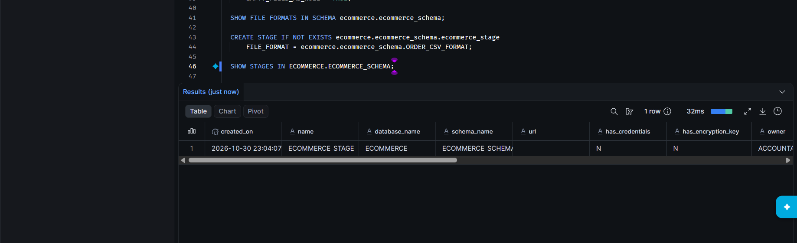

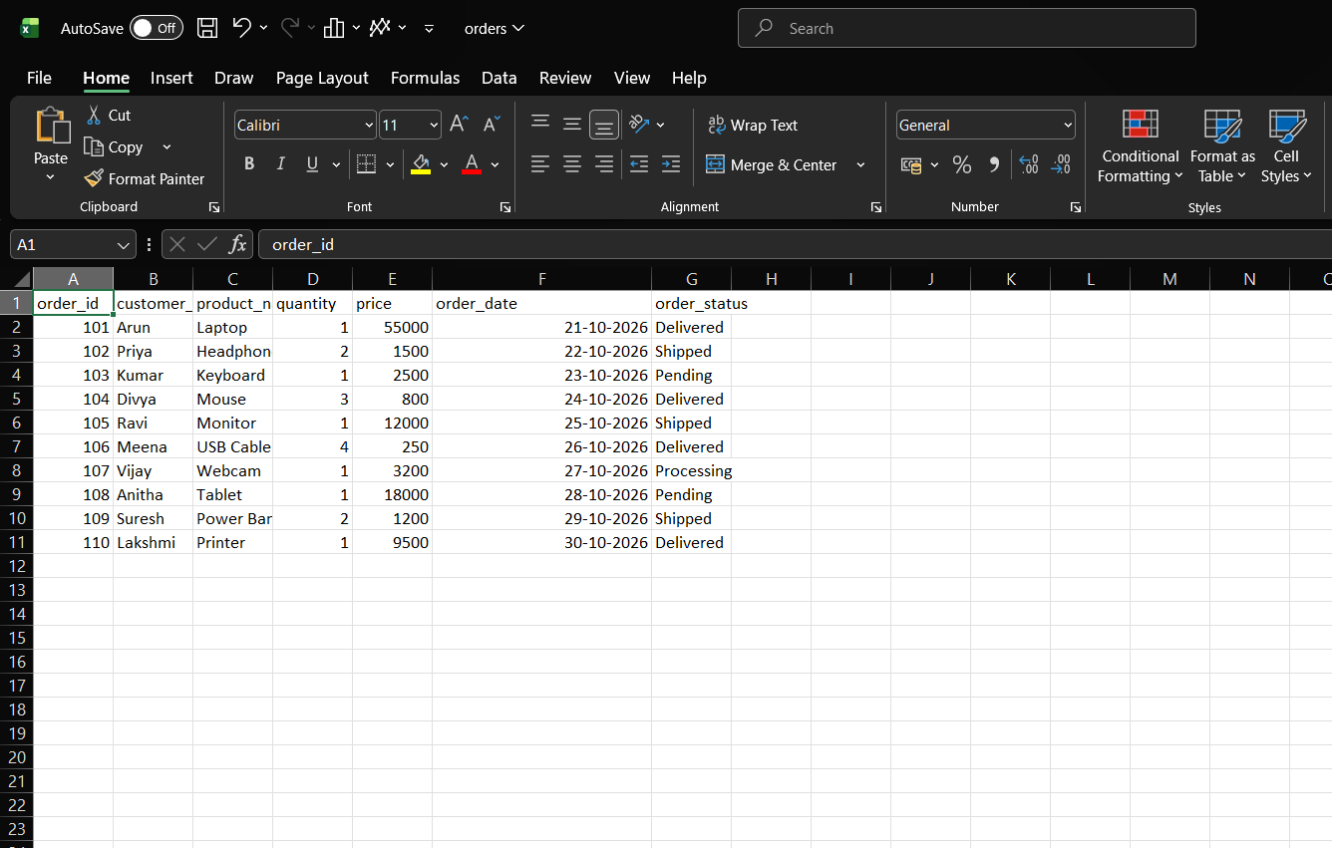

- To upload this dataset I have to catalog and in the databases -> to ecommerce_schema-> stages-> ecommerce_stage and upload the file
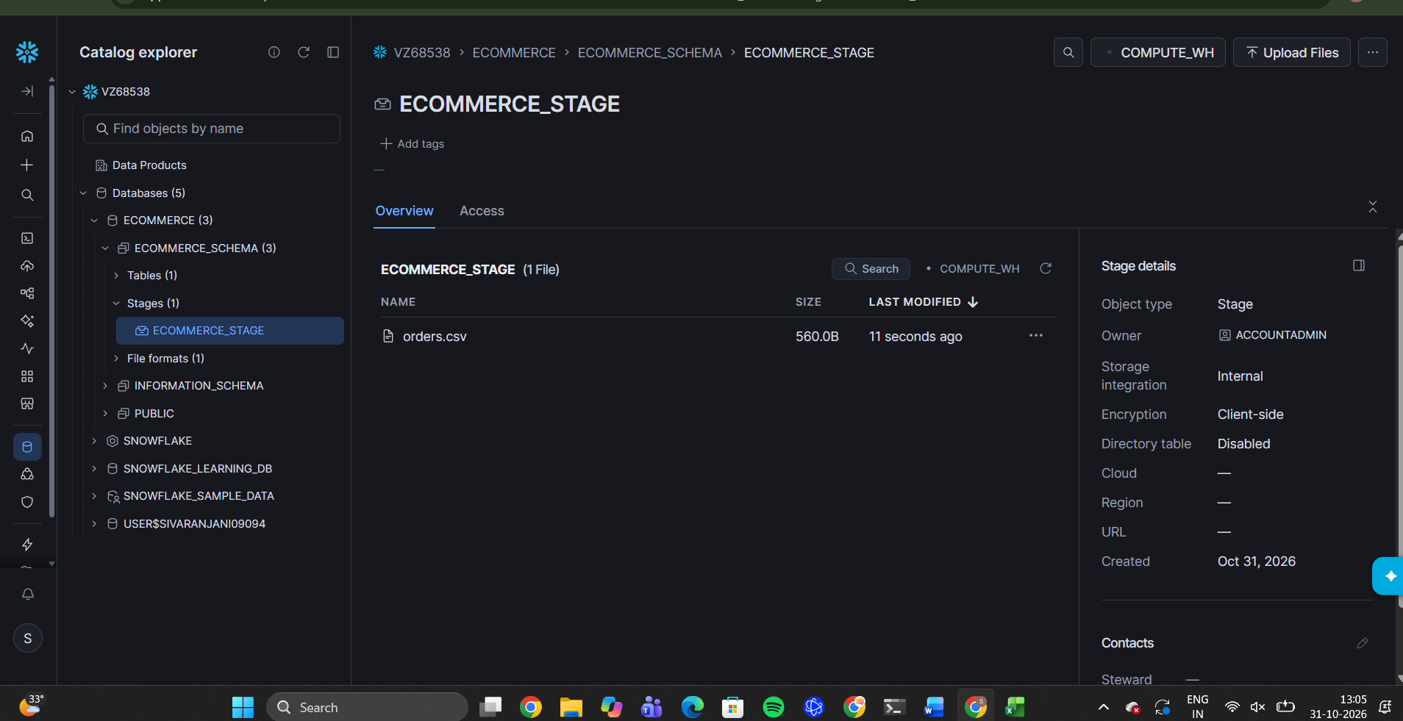

Copy into the table
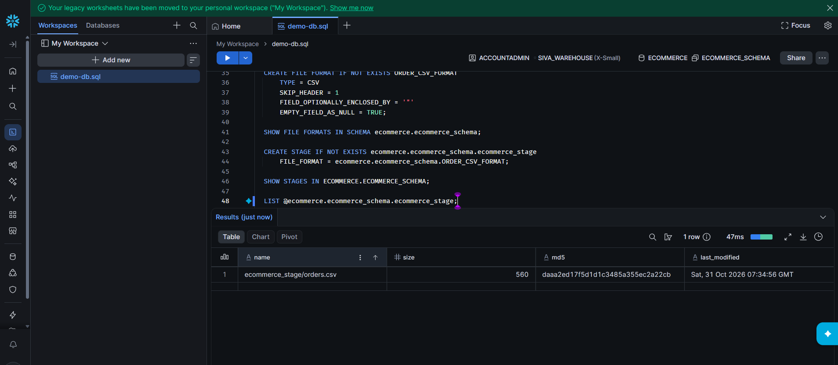

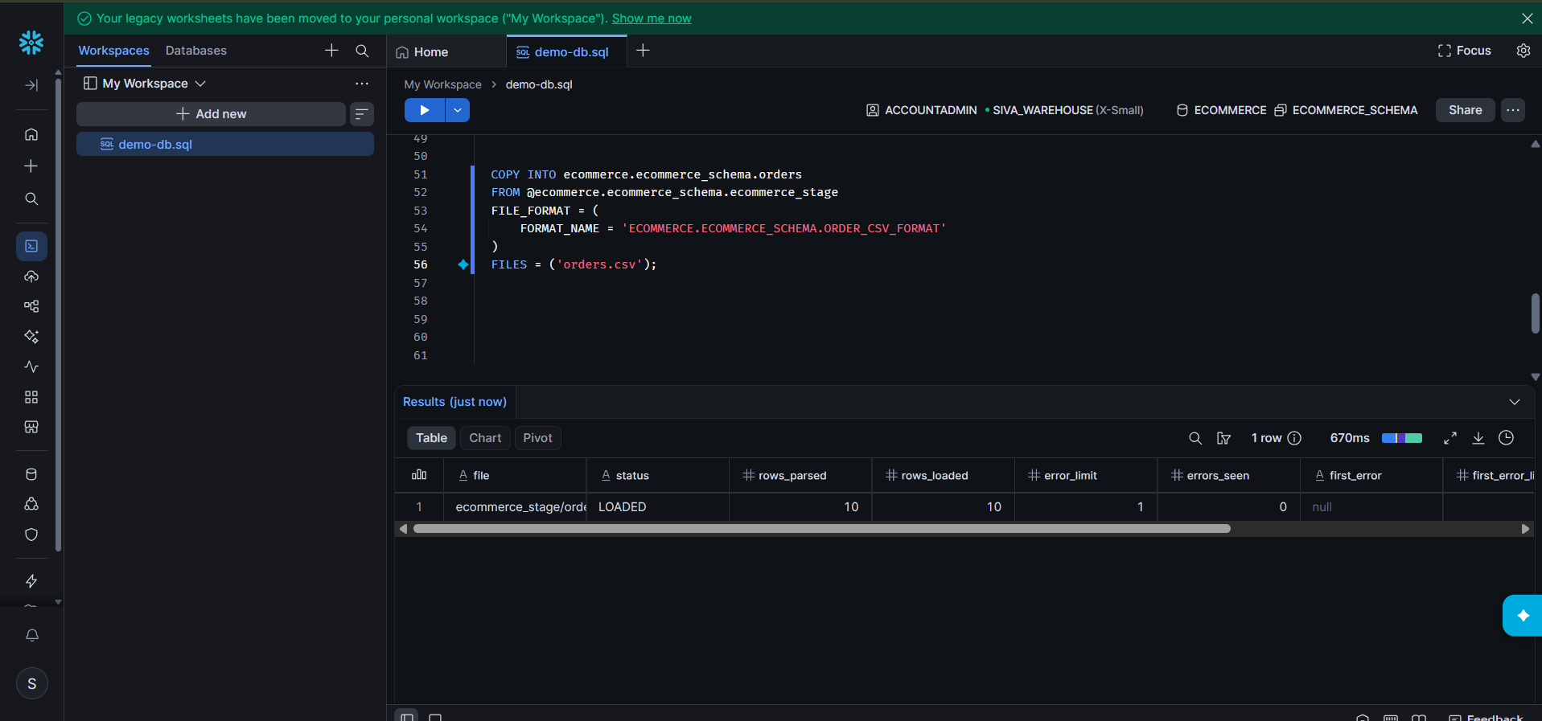

Loaded datas
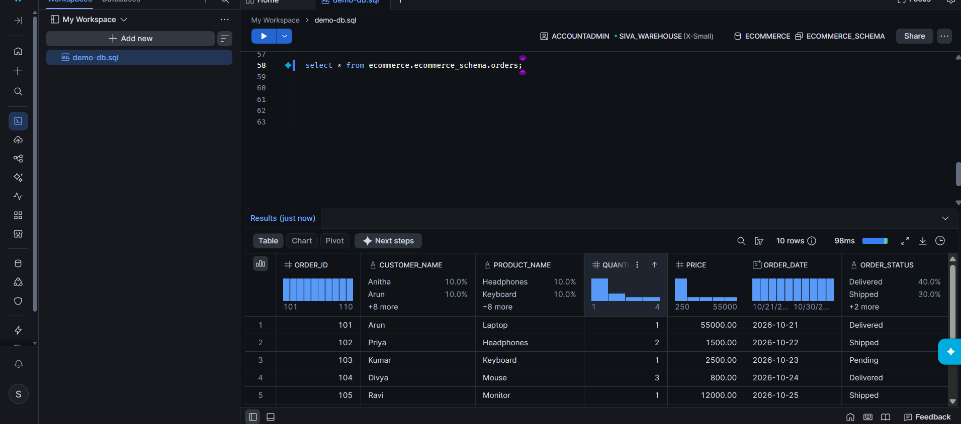

- Grouping and charts in snowflake
